[MyEducator Home Page](https://www.myeducator.com/)

* [BMIS 441 02: Database Manag...](https://app.myeducator.com/course/activity/617eba/2783218111702482945/#)
* [Contents](https://app.myeducator.com/course/activity/617eba/2783218111702482945/#)
* Course
* Nathan Yoon

# **BMIS 441 02: Database Management [Fall 2021]**

## **SQL Assignment #11-Create Tables & Views**

As you learned in Chapter 2 problems, in order to make modifications to database tables and records, you need to have your own database schema.

In this and the following problems, you will use your student credentials to first create tables with and extract data from Redcat Shoes and then modify the data in those tables.

Because you are using your own database schema, you are not automatically connected to Redcat shoes. To retrieve data from the Redcat Shoes database the required syntax is to prefix table names with the database name. For example to access data in the Purchase table, you will specify it as "redcat.purchase".

Also remember that as you build tables and views and populate them with data in your own database schema, the tables and data remain unless you remove it. If you make a mistake or want to rerun your SQL you will need to remove tables. To do so use the Drop Table statement.

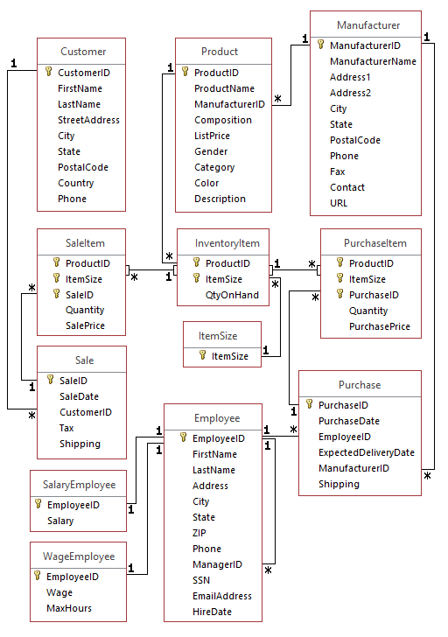

| Due Date: | Nov 07 at 23:59 |
| --- | --- |
| Points: | 100 |

Graded on Nov 12 at 14:30

Your Submission:

| Submission Score: | 98 / 100 (98.00%) |
| --- | --- |
| Grade Time: | Nov 12 at 14:30 |
| Submitted On: | Nov 06 at 16:02 |

1. **Create a new table (name it Purchase61) and insert into it the Purchase records of employee 61 that were made between December 26, 2014 and December 31, 2014. (Use between. Use date format of 'yyyy-mm-dd')**Note: You will be working in your own workspace. To get access to tables in the Redcat database workspace, you will need to add a prefix, i.e. Redcat.Purchase.
2. CREATE TABLE Purchase61 AS
3. SELECT *
4. FROM Redcat.Purchase
5. WHERE EmployeeID = 61
6. AND PurchaseDate BETWEEN '2014-12-26'
7. AND '2014-12-31';
8. SELECT *
9. FROM Purchase61

**FEEDBACK**20 / 20 (100.0%)

1. **Delete from Purchase61 the records for the manufacturer whose ID is 630.**
2. DELETE FROM Purchase61
3. WHERE ManufacturerID = '630';
4. SELECT *
5. FROM Purchase61

**FEEDBACK**20 / 20 (100.0%)

1. Continue to use the Purchase61 that you created and modified in the previous problems.   
   **Increase the shipping cost of every purchase from Manufacturers in Massachusetts ('MA') by 10%. Round your calculations to two decimal points.**Hint: Use the IN clause. Do not use a Join.
2. UPDATE Purchase61
3. SET Shipping = Shipping * 1.10
4. WHERE ManufacturerID IN (
5. SELECT ManufacturerID
6. FROM Redcat.Manufacturer
7. WHERE State = 'MA');
8. SELECT*
9. FROM Purchase61

**FEEDBACK**18 / 20 (90.0%)  
  
Update Purchase61  
set Shipping = round ((Shipping * 1.10),2)  
where manufacturerID in  
 (select manufacturerID  
 from redcat.manufacturer  
 where state = 'MA');

1. In these following problems you will create Views. This is an update to the schema and thus will be done in your own database schema.   
   While you are testing your script before you submit it, if you create the View incorrectly and need to redo it, you will need to use the "Drop View [viewname]" SQL statement to reset your schema. Do not include any Drop statements in your final submission.   
   **Create a view of all the data in the Manufacturer table, but only include data from manufacturers in Ohio, Indiana, Michigan, or Illinois. Name the view MidwestManufacturer and the state names were stored as 'OH', 'IN', 'MI', and 'IL'.**
2. CREATE VIEW MidwestManufacturrer AS
3. SELECT *
4. FROM Redcat.Manufacturer
5. WHERE State IN ('OH', 'IN', 'MI', 'IL');
6. SELECT *
7. FROM MidwestManufacturer
8. **FEEDBACK**20 / 20 (100.0%)  
     
   Create View MidwestManufacturer as Select * from redcat.Manufacturer where state in ('OH', 'IN', 'MI', 'IL');
9. **Create a view of the information about women’s shoes made in CA. The view contains only ProductName, ManufacturerName, Category, Color, ListPrice.**
10. CREATE VIEW WomenCAShoes AS
11. SELECT ProductName, Category, Color, ListPrice, ManufacturerName
12. FROM Redcat.Product, Redcat.Manufacturer
13. WHERE ManufacturerName IN (
14. SELECT ManufacturerName
15. FROM Redcat.Manufacturer
16. WHERE State = 'CA')
17. AND Gender = 'F';
18. SELECT *
19. FROM WomenCAShoes

**FEEDBACK**20 / 20 (100.0%)

Copyright © 2022 MyEducator. All rights reserved.

[Need Help?](https://myeducator.freshdesk.com/support/home)